SOFTWARE TESTING
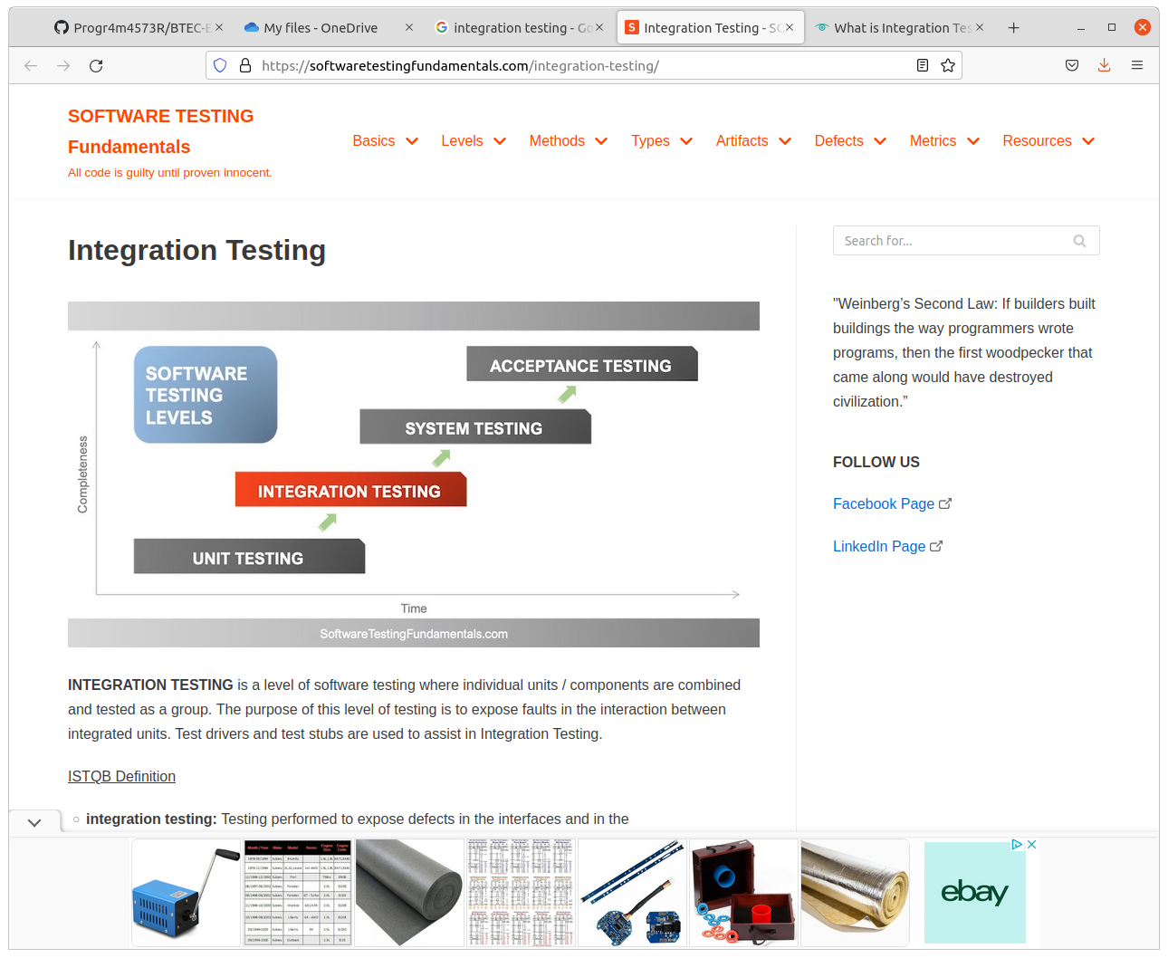
Unit Testing

An integral part of the software development process.
It requires independently and indiscriminately scrutinising the smallest parts of an application (units)
The goal being to isolate written code and determine if it works as expected. If done correctly, this detects early flaws in code that can be hard to find in later stages.
Unit testing occurs in the first level of software development.
It is performed before any other testing and makes sure units don’t rely on external codes or functions. It is comprised of 3 stages:
- Preparing and reviewing the unit in questions
- Making test cases and scripts
- Testing the code
To keep programs working efficiently, unit tests should be performed frequently, manually or automatically by developers or QA teams

Advantages
- Early detection of problems reduces compound errors
- Fixing a problem early is usually cheaper than fixing it later
- De-budding is made easier
- Developers are able to quickly change code base
- Developers can reuse code and migrate it to new projects

Disadvantages
- Unit testing is not a guaranteed way to ensure proper code operation
- Tests don’t uncover every bug
- Unit tests don’t catch errors in integration with other data sets
- Multiple lines of test code may need to be written to test one line of code
- Unit testing may have a steep learning curve

Black box testing – A method of software testing that examines the functionality of an application without peering into its internal structures or workings. This method of test can be applied virtually to every level of software testing, unit, integration, system and acceptance

White box testing - a software evaluating method used to examine the internal structure, design, coding and inner-working of software. Developers use this testing method to verify the flow of inputs and outputs through the application, improving usability and design and strengthening security.

Integration testing - also known as integration and testing (I&T) -- is a type of software testing in which the different units, modules or components of a software application are tested as a combined entity. However, these modules may be coded by different programmers.

System testing, also referred to as system-level tests or system-integration testing, is the process in which a quality assurance (QA) team evaluates how the various components of an application interact together in the full, integrated system or application.

Acceptance testing is a quality assurance (QA) process that determines to what degree an application meets end users' approval. Depending on the organization, acceptance testing might take the form of beta testing, application testing, field testing or end-user testing.

